Khlood Ahmed
Salma Mohamed
Malak Tamer
Istabraq El Gendy
Hamza Bayoumi
Ahmed Hassan
Turning digital-behavior survey data into mental-health risk insights through Python, a Star Schema data model, and an interactive Power BI dashboard
Digital Lifestyle & Mental Health Analytics
GRADUATION PROJECT
Digital lifestyle Documentation

Abstract
This project investigates the relationship between digital lifestyle habits, such as smartphone and social media usage, phone unlock frequency, and notification exposure, and mental health outcomes, with a particular focus on depression. The Digital Lifestyle Benchmark Dataset (100,000 respondents, 24 variables) was collected, cleaned, and analyzed using Python (Pandas, NumPy, Matplotlib) and Microsoft Excel.
The analysis explored correlations between digital behavior indicators (device usage hours, phone unlocks, notifications, social media minutes) and psychological indicators (depression, anxiety, stress, happiness, sleep quality). The dataset was segmented across demographic dimensions: gender, region, income level, education, occupation, and device type to identify high-risk groups and behavioral patterns.
Key findings show that daily device usage hours, phone unlock frequency, and overall digital dependence are the strongest behavioral predictors of depression scores in the sample, while sleep duration and sleep quality show a strong protective (negative) relationship with depression. Approximately one in five respondents (20.1%) were flagged as high-risk. These insights support the development of an interactive Power BI dashboard and provide actionable recommendations for individuals, educators, and healthcare professionals seeking to promote healthier digital habits.

Table of Contents
Serial | Contents
1 | Project Overview
1.1 | Project Concept
1.2 | Data Source
1.3 | Project Impact
1.4 | SMART Questions
2 | Technical Architecture
2.1 | Tools Used
2.2 | Architecture (Medallion)
2.3 | Data Model
3 | Dashboard & Visualization
3.1 | Power BI Dashboard Pages
3.2 | KPI Highlights
3.3 | Figma Design
3.4 | Dashboard
4 | Machine Learning Module
4.1 | Overview
4.2 | Dataset Preparation and Target Variable
4.3 | Feature Selection and Data Preprocessing
4.4 | Model Training and Evaluation
4.5 | Model Deployment

- Project Overview
This documentation presents an interactive analysis of digital lifestyle behavior and its relationship to mental health. It is designed to help readers explore usage patterns, understand key risk factors, and gain data-driven insights that support healthier digital habits and better-informed decision-making.

  - Project Concept
This project focuses on analyzing the relationship between digital lifestyle behaviors and mental health outcomes, particularly depression, using data analytics and interactive visualization. The dataset was cleaned, validated, and structured to support efficient exploration in Excel and Power BI.
The project aims to identify behavioral and demographic risk factors, such as excessive screen time, high phone-unlock frequency, poor sleep, and low physical activity, that are associated with elevated depression, anxiety, and stress levels. Statistical analysis (correlation and group comparison) was used to quantify these relationships across genders, regions, income levels, education levels, occupations, and device types.
The final solution combines Python for data cleaning and statistical analysis with Excel for data preparation and Power BI for interactive dashboard reporting, providing insights that can support digital-wellness awareness and evidence-based recommendations.

  - Data Source
The data used is the Digital Lifestyle Benchmark Dataset (2025), containing 100,000 respondent records and 24 variables covering demographics (age, gender, region, income, education, occupation), digital behavior (device hours, phone unlocks, notifications, social media minutes, device type), lifestyle factors (sleep hours and quality, physical activity days, study minutes), and psychological indicators (depression, anxiety, stress, happiness, focus, productivity, and a composite digital-dependence score).
- File: digital_lifestyle_benchmark_2025.csv
- Records: 100,000 respondents
- Variables: 24 columns (numerical and categorical)
- Data quality: no missing values and no duplicate records were found during inspection
Link : https://huggingface.co/datasets/tarekmasryo/digital-lifestyle-benchmark-dataset/tree/main/data

  - Project Impact
This project turns raw survey data into meaningful analytics that highlight how digital habits relate to psychological well-being. By quantifying the relationship between screen time, sleep, physical activity, and mental health indicators, the project helps identify high-risk behavioral profiles and demographic groups most affected.
The resulting dashboard and insights can support digital-wellness awareness campaigns, inform healthier-usage recommendations from healthcare professionals and educators, and demonstrate the practical use of data engineering and business-intelligence techniques on a real-world behavioral dataset.

  - Smart Business Questions
- How strongly is daily device/screen usage time related to depression levels?
- Which age groups experience the highest average depression scores?
- What is the relationship between sleep duration and quality and mental health indicators?
- Which factors sleep, physical activity, or reduced screen time show the strongest protective association with depression?
- Which occupational/daily-role groups are associated with the highest depression rates and risk levels?
- How do male and female respondents differ in depression occurrence?
- Which social media usage tiers are linked to the highest high-risk rates?
- Which device types and usage conditions contribute most to elevated depression scores?
- What percentage of respondents fall into the minimal, mild, moderate, or severe depression bands?
- Are unemployed or job-seeking respondents more at risk than full-time employees?
- Can statistical or predictive models accurately estimate depression risk from digital-behavior data?
- Which behavioral and lifestyle conditions represent the highest mental-health risk factors?
- How can predictive analytics support digital-wellness awareness and decision-making?

- Technical Architecture
The project follows a straightforward analytics workflow that integrates Python, Excel, and Power BI to clean, analyze, and visualize the Digital Lifestyle Benchmark Dataset.

  - Tools used
Data Processing & Analysis:
- Python
- Pandas
- NumPy

Data Visualization:
- Power BI
- Machine Learning & Forecasting
- Python Machine Learning Models

Data Source & Storage:
- huggingface Dataset
- CSV Files
- Data Modeling
- Star Schema Modeling
- DAX (Data Analysis Expressions)

Development Environment:
- Google Colab

  - Medallion Architecture
The project follows a simplified Medallion Architecture approach to organize and transform the Digital Lifestyle Benchmark dataset through multiple processing layers, improving data quality, analytical reliability, and reporting efficiency.

Bronze Layer: Raw Data
The raw dataset was collected in CSV format and stored without modification. This layer preserves the original respondent records for traceability and future reference.
Key Characteristics:
- Raw Digital Lifestyle Benchmark dataset
- Original CSV file, 100,000 rows × 24 columns
- Unprocessed, as-collected survey data
- Initial ingestion and inspection using Python (Pandas)
Link : https://colab.research.google.com/drive/1v7ZUyeolg3qtTJyvOpjvPrnINMy_bP3G?usp=sharing

Silver Layer: Cleaned & Transformed Data
In this layer, the dataset was inspected, validated, and transformed using Python and Excel. Data types, value ranges, and category labels were checked and standardized to improve data quality and analytical usability.
The raw dataset required several preprocessing steps before analysis could begin. Using Python, the following operations were performed:
- Loading and inspecting the Bronze Layer dataset containing 100,000 rows and 24 columns
- Validating missing values and checking for duplicate records across all columns (none found)
- Standardizing categorical columns including gender, region, income level, education level, daily role, and device type
- Applying business rules to remove records with illogical values, such as ages outside the 10 to 100 range, sleep hours outside 0 to 24, and physical activity days outside 0 to 7
- Outlier and range inspection for numerical fields (e.g., sleep_hours, depression_score)
- Creating new analytical columns including age group, screen time category, sleep category, mental health risk level, and productivity category
- Calculating a composite digital wellness score by combining happiness, focus, and sleep quality into a single normalized metric
- Rounding all float columns to 2 decimal places for consistency
Output: cleaned_digital_lifestyle_data.csv
Link : https://colab.research.google.com/drive/1oMbCfY9z1aM166DaljN8iELAwU-wCEtj?usp=sharing

Gold Layer: Analytics & Business Intelligence
The Gold layer contains business-ready datasets optimized for reporting, machine learning, and dashboard analysis in Power BI.
Components:
- Fact and Dimension tables
- Star Schema model
- DAX measures and KPIs
- Machine learning predictions
- Forecasting outputs
- Interactive dashboards
The final dashboards provide:
- Depression and mental-health risk analysis
- Digital-behavior and lifestyle condition insights
- Demographic and occupational risk-factor comparisons
- Interactive business-intelligence reporting
Link : https://colab.research.google.com/drive/1sgbk20eORhI2mQDCK4tS8fBpWSE7eyru?usp=sharing

  - Data Model
The project uses a Star Schema data model to improve query performance, simplify analysis, and support efficient dashboard reporting in Power BI. The model is centered around a fact table containing respondent-level behavioral and psychological metrics, connected to four-dimension tables that provide descriptive and categorical context.
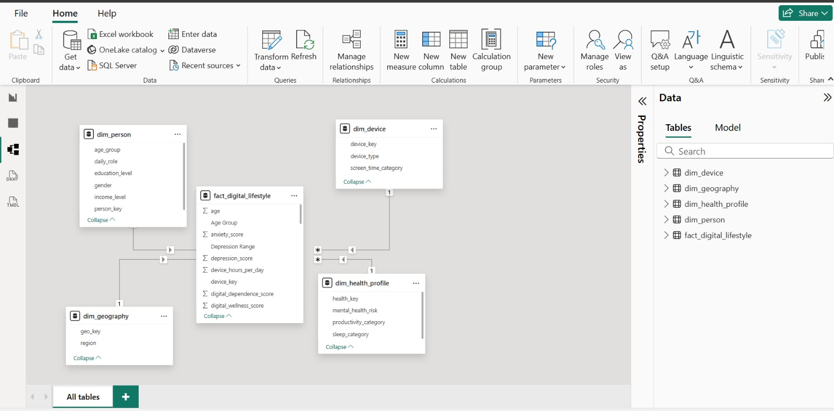

Fact Table: fact_digital_lifestyle
The central fact table stores each respondent's digital-behavior and mental-health metrics used for analysis and reporting.
Key Measures:
  - age
  - anxiety_score
  - depression_score
  - device_hours_per_day
  - digital_dependence_score
  - digital_wellness_score

Calculated Columns:
  - Age Group
  - Depression Range

Foreign Keys:
  - person_key
  - device_key
  - geo_key
  - health_key

Dimension Tables
- dim_person
Contains demographic and lifestyle classification attributes for each respondent.
Attributes:
  - person_key
  - age_group
  - gender
  - daily_role
  - education_level
  - income_level

- dim_device
Stores device type and screen-time classification information.
Attributes:
  - device_key
  - device_type
  - screen_time_category

- dim_geography
Stores regional classification information.
Attributes:
  - geo_key
  - region

- dim_health_profile
Defines mental-health risk and lifestyle classification categories.
Attributes:
  - health_key
  - mental_health_risk
  - productivity_category
  - sleep_category

Relationships
The fact table is connected to each dimension table using one-to-many relationships (1 on the dimension side, * on the fact side), enabling flexible filtering, drill-down analysis, and interactive reporting within Power BI.

Model Benefits
  - Optimized analytical performance
  - Simplified DAX calculations
  - Faster dashboard interaction
  - Improved scalability and maintainability
  - Better support for machine learning integration and forecasting analysis

- Dashboard & Visualization

  - Power BI Dashboard Pages
- Executive Summary
- Demographics
- Device Usage
- Social Media
- Sleep Analytics
- Mental Health
- Productivity
- High Risk Users
- Physical Activity
- Correlations
- Segmentation

  - KPI Highlights
The dashboard was built around a set of core KPIs that appear across the 11 pages, each chosen to reflect a specific dimension of the digital lifestyle dataset. These metrics serve as the primary indicators that the analysis revolves around.

- Total Population: 100,000
The full dataset contains 100,000 participants, representing the baseline for all percentages, averages, and comparisons made throughout the dashboard.

- Average Age: 31 Years
The average participant age, used to contextualize behavioral patterns across demographic breakdowns.

- Gender: 47.4% Male / 52.6% Female
A near-balanced gender distribution across the population, ensuring gender-based comparisons are statistically meaningful..

- Average Device Hours: 7.3 Hours/Day
The average daily screen time across all participants serving as the central metric for measuring digital dependency and its downstream effects on health and productivity.

- Average Phone Unlocks: 145 Unlocks/Day
Indicates compulsive checking behavior, used as a supporting metric for digital dependence analysis.

- Average Notifications: 336 Notifications/Day
Measures environmental digital interruptions and their relationship to stress and focus scores.

- Average Social Media Minutes:156.1 Minutes/Day
Nearly 2.5 hours of daily social media use on average, making this one of the most significant variables in the mental health analysis.

- Average Sleep Hours: 7.3 Hours
Used to explore relationships between rest and productivity, stress, focus, and depression scores.

- Average Focus Score : 41.6 out of 100
A below-midpoint focus score indicating that the sample population struggles with sustained attention, likely linked to high device and social media usage.

- Average Stress Level: 5.08 out of 10
A moderately high stress level across the population, used as a key mental health output variable.

- Average Anxiety Score: 7.2 out of 10
Paired with stress and depression scores to build a complete picture of mental wellness across segments.

- Average Happiness Score: 6.4 out of 10
Used to measure overall well-being and its relationship with physical activity, sleep, and device usage.

- High Risk Users: 20,066 users, representing 20.1% of the total population
The most critical KPI in the dashboard, identifying the 20,066 participants flagged for digital addiction and mental health risk, which drives the entire high risk user analysis page.

  - Figma Design

Landing Page
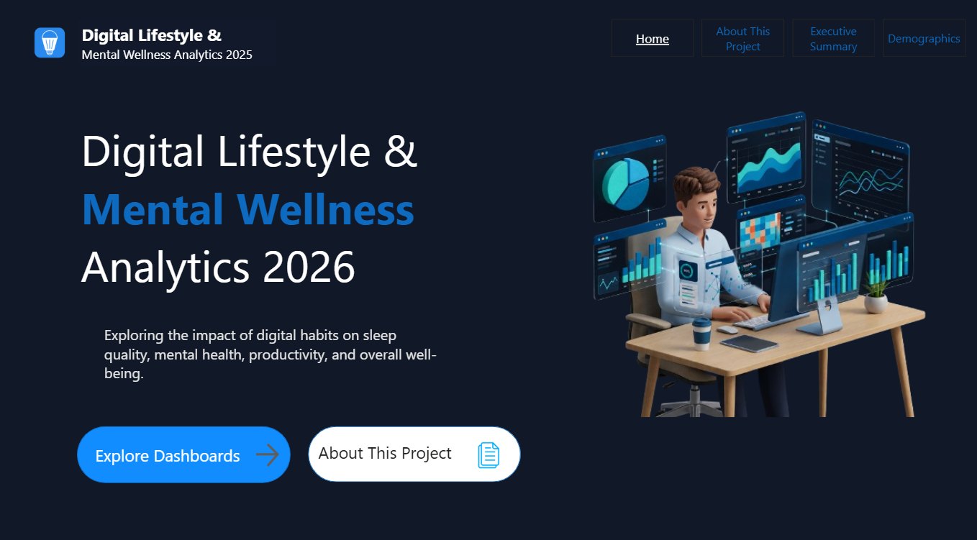

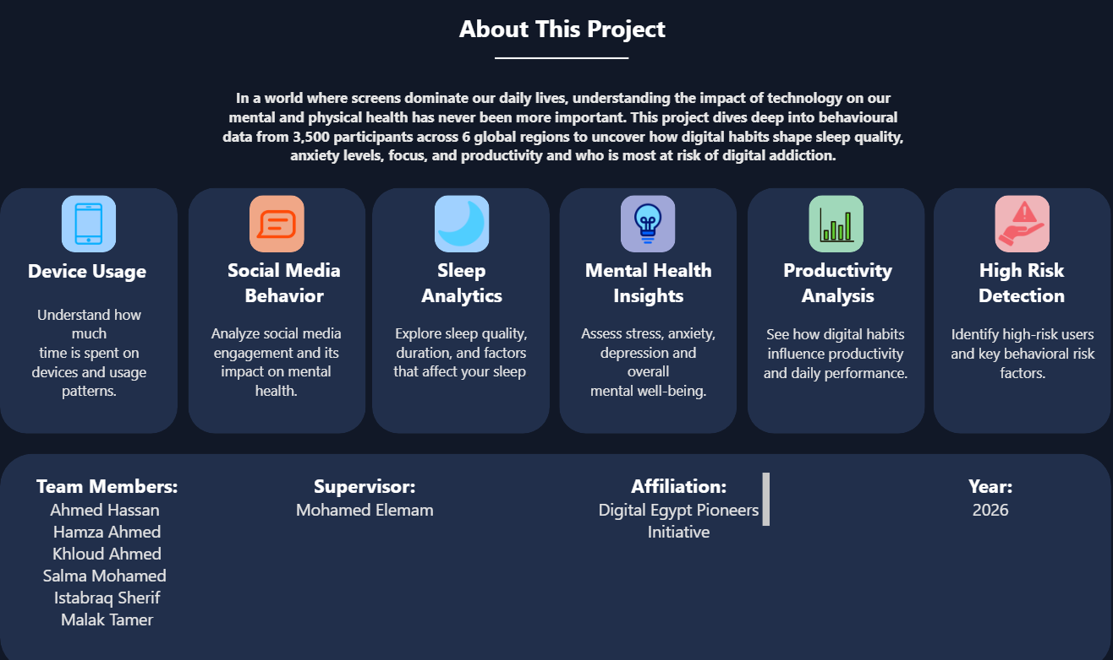
Overview

Excutive Summary
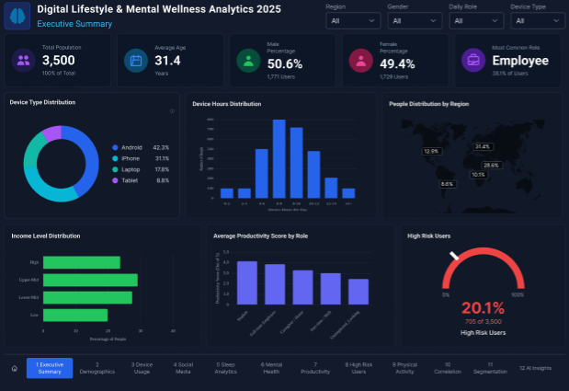

Demographic
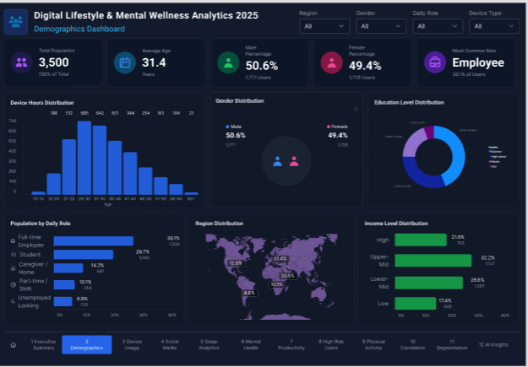

Device Usage Analysis
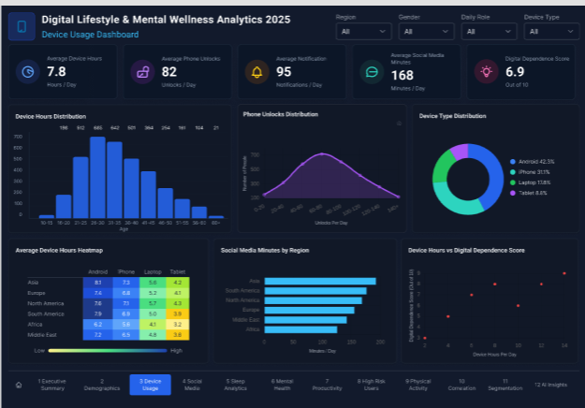

Social Media Analysis
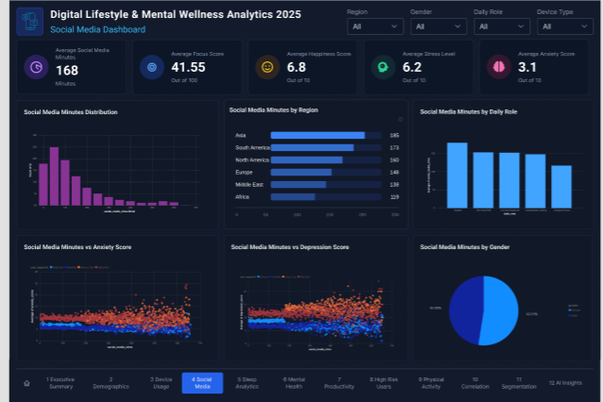

Sleep Analysis
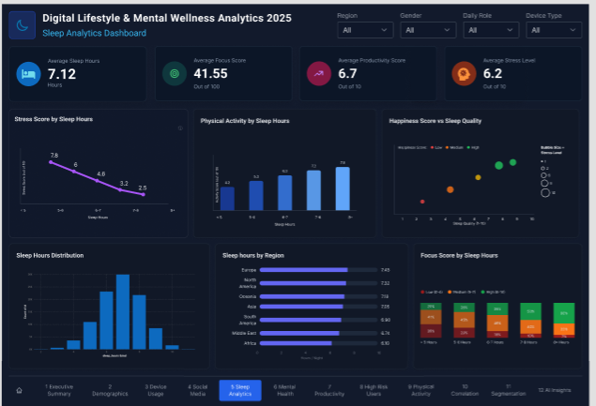

Mental Health Analysis
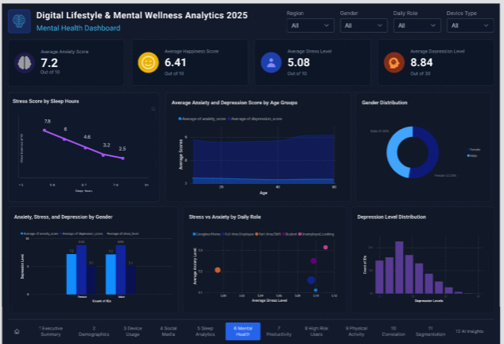

Productivity Analysis
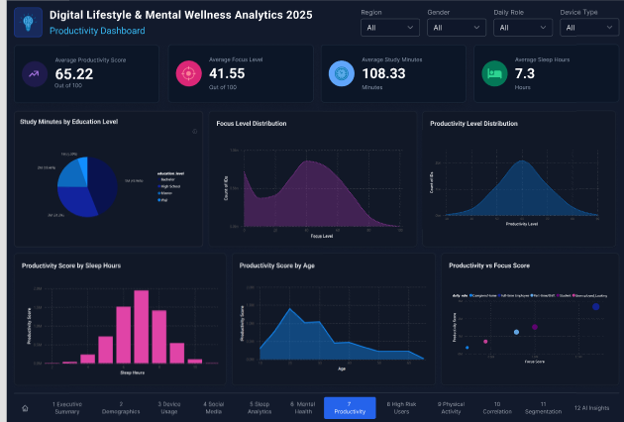

High Risk Analysis
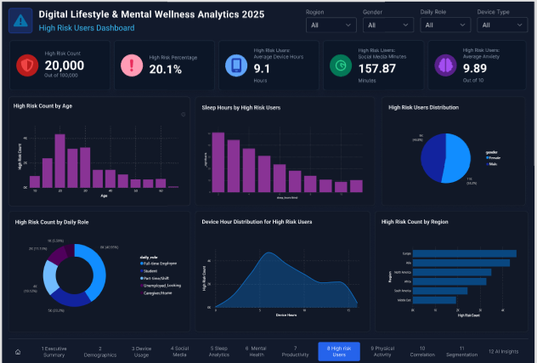

Physical Activity Analysis
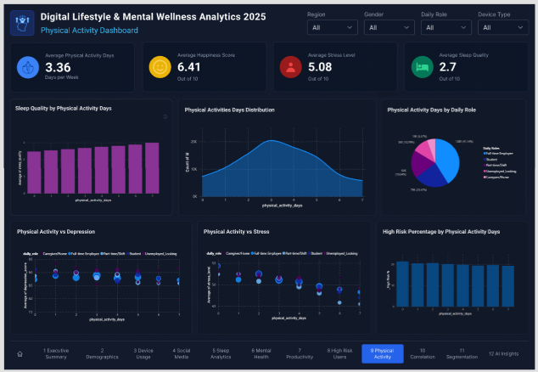

Correlation Analysis
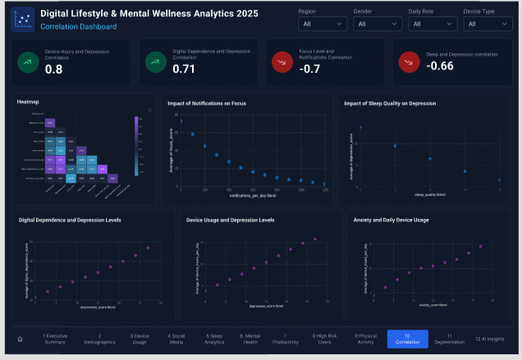

Segmentation Analysis
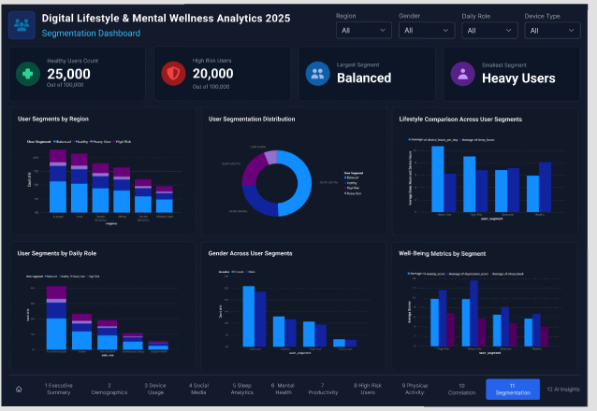

Link: https://www.figma.com/design/R5KiScflgiuqss9lJYlVwh/depi-project?node-id=0-1&t=XBDYHYXAQt28oPLw-0

  - Dashboard
Excutive Summary
Snapshot of the entire population (100K users, average age 31, gender split). Highlights device usage, regional spread, income, and productivity. Flags overall High Risk Users at 20.1%.
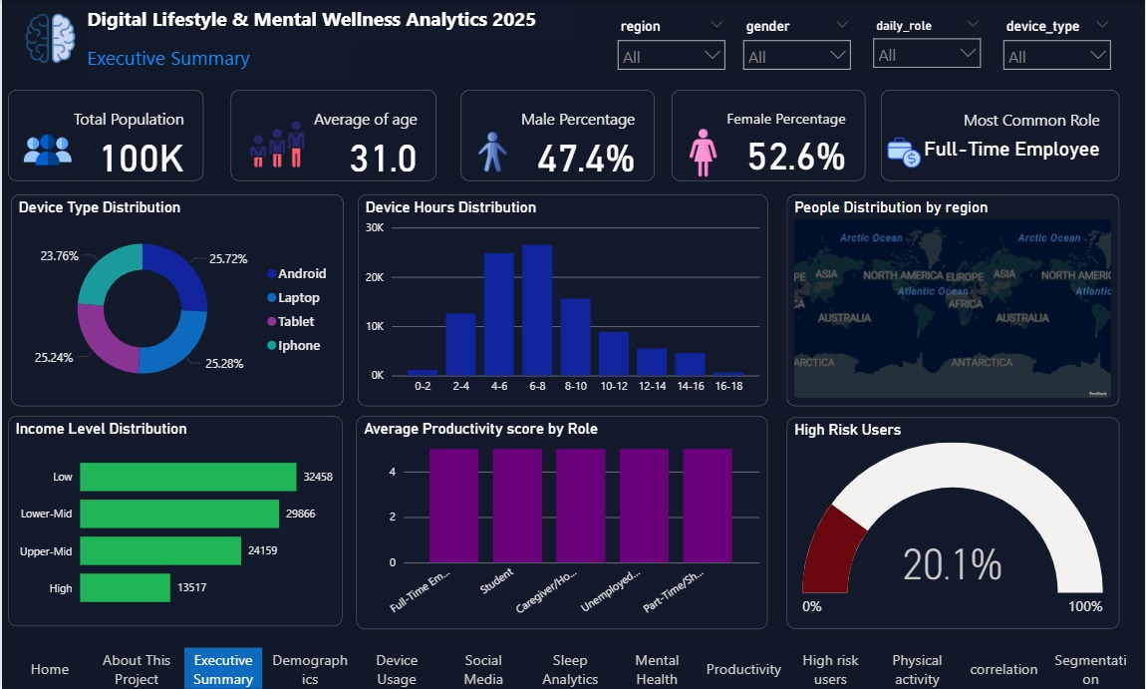
Demographic
Breaks down population by age, gender, education, role, region, and income. Full-Time Employees are the most common role; Bachelor's degree holders are the largest education group.
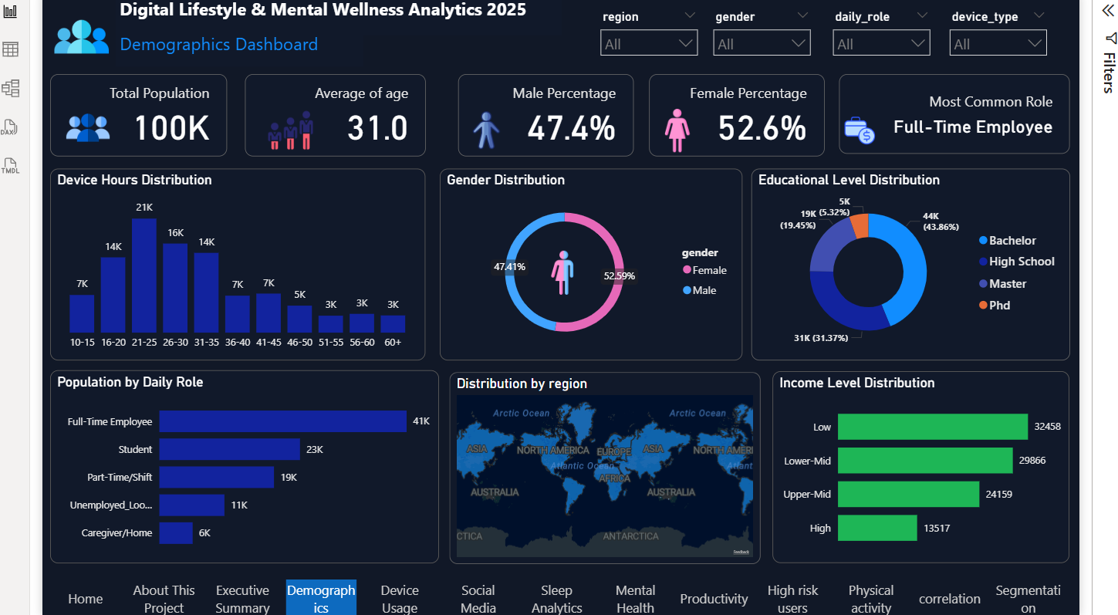
Device Usage Analysis
Covers device hours, phone unlocks, notifications, and social media minutes. Includes a Digital Dependence Score compared across regions and device types.
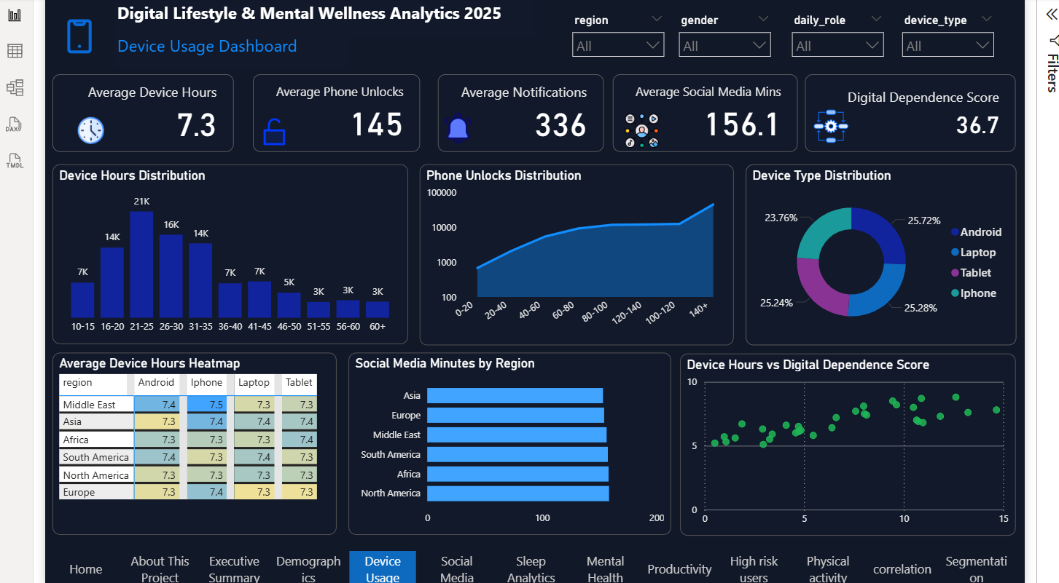

Social Media Analysis
Tracks social media usage and its emotional impact (focus, happiness, stress, anxiety). Compares usage across regions, roles, and gender.
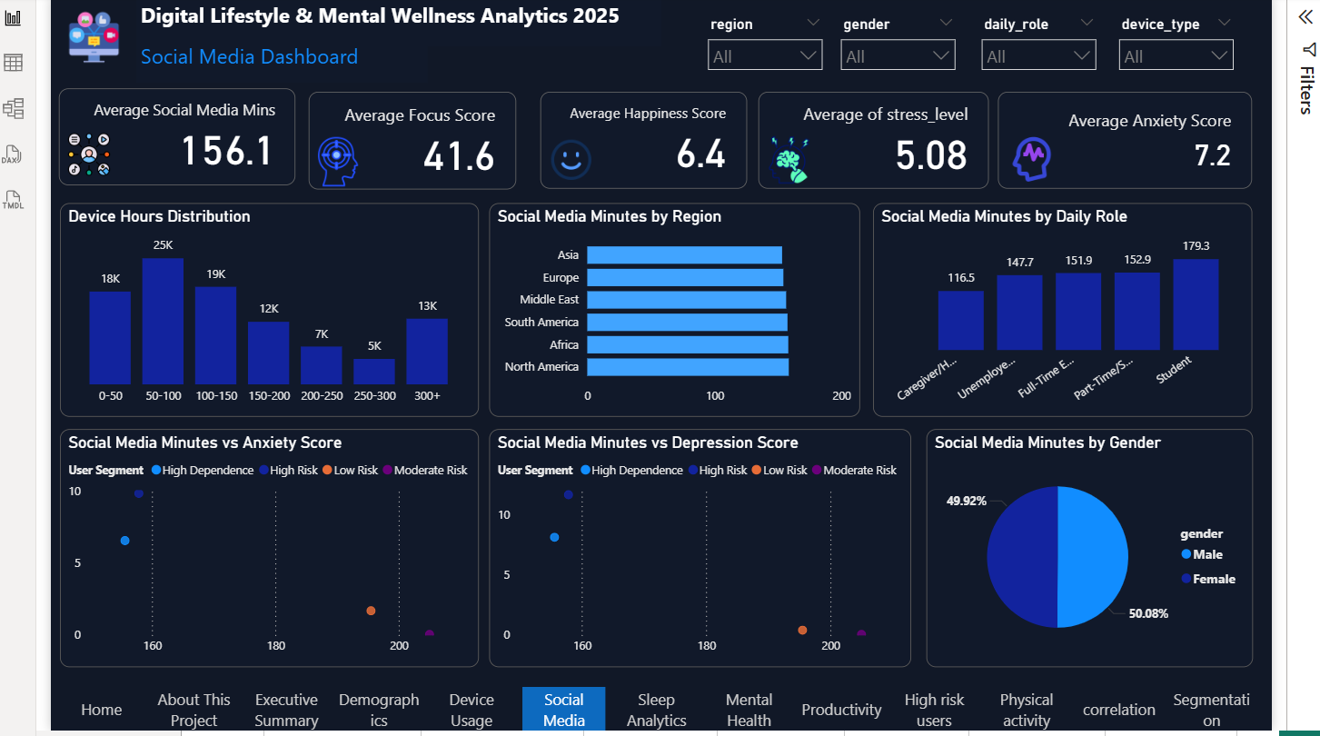
Sleep Analysis
Examines sleep patterns and their link to stress, focus, and productivity. Shows sleep hours distribution by region and how stress decreases as sleep increases. Compares physical activity and focus scores across sleep duration groups.
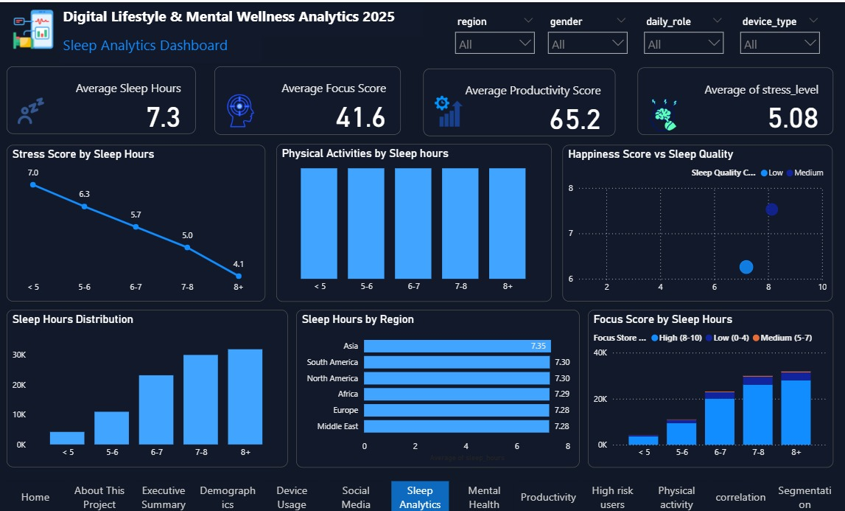
Mental Health Analysis
Centers on anxiety, happiness, stress, and depression levels. Shows how these vary by age, gender, sleep, and daily role.
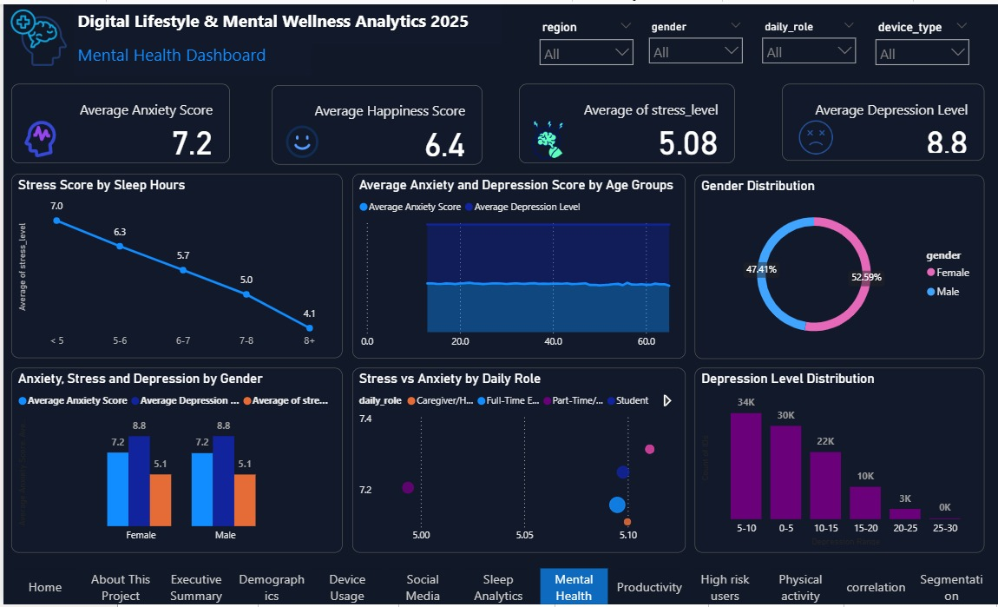
Productivity Analysis
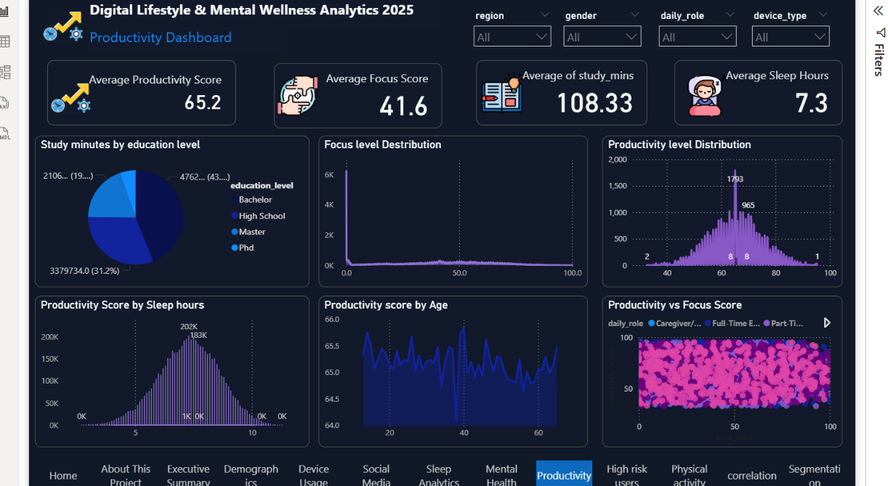
Measures productivity and focus scores alongside study time and sleep hours. Explores how sleep and age relate to productivity.

High Risk Analysis
Isolates the 20,066 high-risk users, detailing their device hours, social media minutes, and anxiety scores. Shows how risk varies by age, sleep, and role.
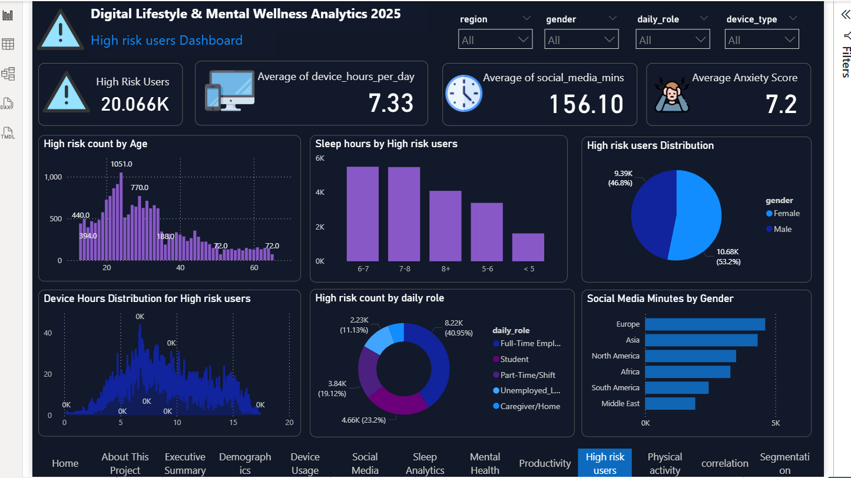

Physical Activity Analysis
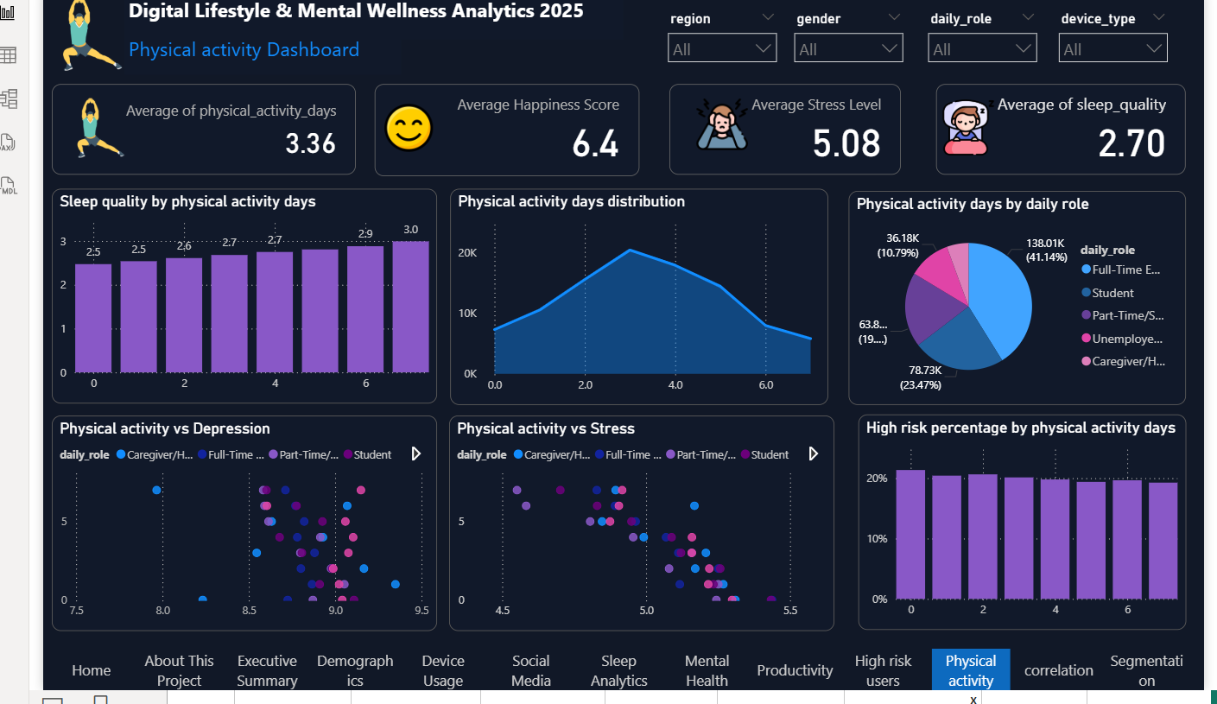
Examines physical activity's link to sleep quality, depression, and stress. Shows how activity levels affect high-risk percentages.
Correlation Analysis
Quantifies key relationships, like device usage vs. depression (0.80) and dependence vs. depression (0.71). Highlights the strongest drivers of mental health risk.
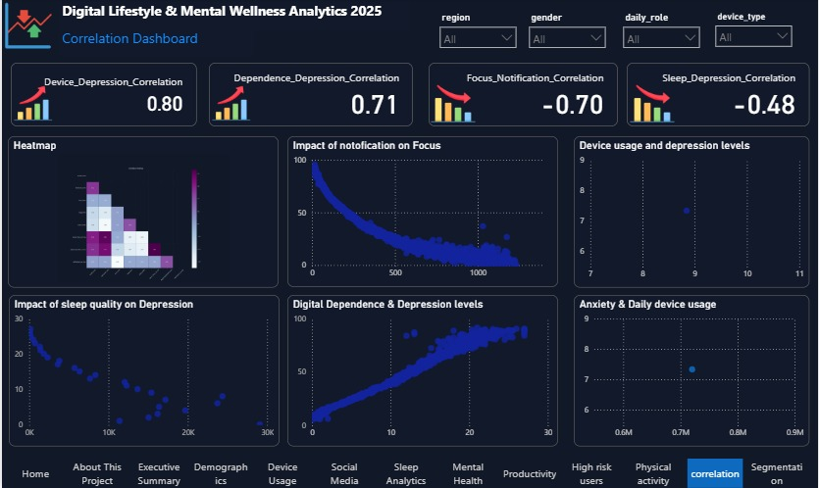
Segmentation Analysis
Groups users into segments (High Dependence, High Risk, Low Risk, Moderate Risk). Shows segment distribution by region and gender, with High Dependence as the largest group.
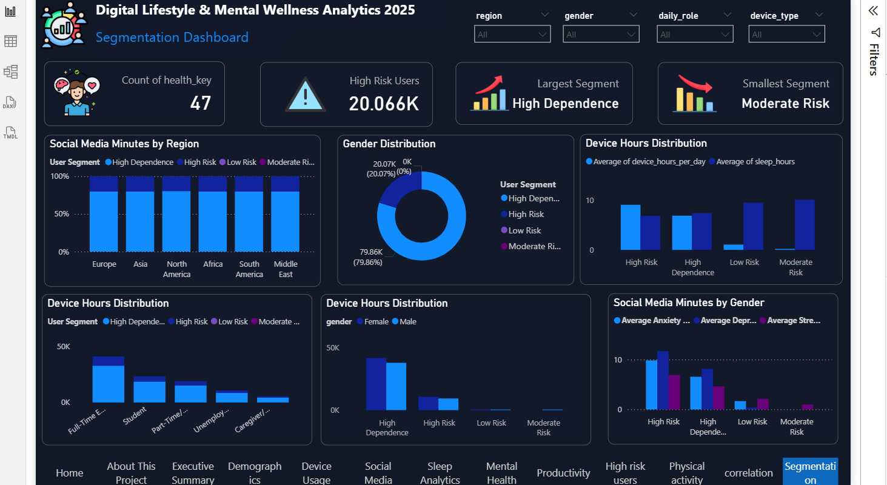

Link: https://github.com/ahmedkhlood413-bit/Depi-Poject/tree/main/Power%20Bi

- Machine Learning Module

  - Overview

The Machine Learning module is one of the core components of the project. Its primary objective is to predict an individual's Mental Health Risk based on their digital lifestyle and social media behavior. Instead of relying solely on traditional clinical assessments, the model analyzes behavioral patterns collected from users' daily digital activities to estimate the likelihood of experiencing mental health risks.

This predictive system enables early identification of individuals who may require additional attention or professional support. By integrating machine learning into the platform, the project provides intelligent, data-driven insights that complement traditional mental health assessment methods.

  - Dataset Preparation and Target Variable

The machine learning pipeline operates on the Gold Layer of the Medallion Architecture, after the data has already been cleaned and standardized in the Bronze and Silver layers.
The final analytical dataset combines information from multiple dimension tables including personal information, device usage, health profile, geographic information, and digital lifestyle records. These tables are merged into a single dataset suitable for machine learning tasks.

Before training the models, several validation steps were performed to ensure data quality:
- Detecting missing values
- Removing duplicate records
- Validating data types
- Identifying potential outliers
- Ensuring overall dataset consistency

These preprocessing steps improve data quality and reduce the impact of noisy or inconsistent records on model performance.

The prediction target is High Mental Health Risk. The dataset contains the target column high_risk_flag, where 0 represents Low Risk and 1 represents High Risk. This transforms the problem into a binary classification task, where the objective is to correctly classify users into one of the two categories.
  - Feature Selection and Data Preprocessing

To improve model reliability and avoid data leakage, unnecessary columns were excluded before training. The following types of columns were removed:
- Primary keys and surrogate keys
- Identifier columns
- Columns directly related to mental health assessment such as anxiety and depression scores
- Variables that could reveal the target value

The remaining features represent users' digital behavior and demographic characteristics, including age, device usage hours, phone unlock frequency, notifications per day, social media usage time, study duration, physical activity, sleep duration, device type, education level, region, and income level.

These variables provide meaningful information while preventing the model from learning the target directly.

Before model training, numerical and categorical variables were processed separately.
For numerical features:
- Missing values were handled using median imputation
- Features were standardized using StandardScaler.

For categorical features:
- Missing values were replaced using the most frequent category
- Categories were converted into numerical representations using One-Hot Encoding.

The preprocessing workflow was implemented using Scikit-learn's ColumnTransformer and Pipeline, ensuring that all preprocessing steps are consistently applied during both training and prediction.

  - Model Training and Evaluation

Three supervised machine learning algorithms were selected and compared:
- Logistic Regression
- Random Forest
- XGBoost
Each model was trained using the same training dataset to ensure a fair comparison. The dataset was divided into 80% training data and 20% testing data using Stratified Train-Test Split, preserving the original distribution of the target classes.

Multiple evaluation metrics were used to assess model performance including:
- Accuracy
- Precision
- Recall
- F1 Score
- ROC-AUC

Since the dataset is moderately imbalanced, the F1 Score was considered the primary evaluation metric because it provides a balanced measure of Precision and Recall. The trained models were compared using these metrics, and the model with the highest F1 Score was selected as the final production model.
Logistic Regression:
- Accuracy: 66.59%
- F1 Score: 44.13%
Random Forest:
- Accuracy: 79.15%
- F1 Score: 13.64%
XGBoost:
- Accuracy: 67.82%
- F1 Score: 43.19%

After selecting the best-performing model, feature importance analysis was conducted to determine which variables contributed most to the prediction. Among the most influential features were:
- Digital Wellness Score
- Digital Dependence Score
- Device Hours per Day
- Focus Score
- Sleep Hours

This analysis provides valuable insights into the relationship between digital behavior and mental health risk.
  - Model Deployment

After training and evaluation, the best-performing model was saved using Joblib. The preprocessing pipeline was also saved separately to ensure that any future input data undergoes the same preprocessing steps used during training.

The trained model was then integrated into a Streamlit application, allowing users to enter their information through a user-friendly interface and receive a real-time prediction of their mental health risk.

The Machine Learning module successfully transforms users' digital lifestyle information into actionable predictions regarding mental health risk. By combining robust data preprocessing, feature selection, model comparison, and deployment within an interactive web application, the system demonstrates how artificial intelligence can support early detection and informed decision-making in mental health monitoring.

AI Analysis
